Modify the ff. alert message based on the alert message below.

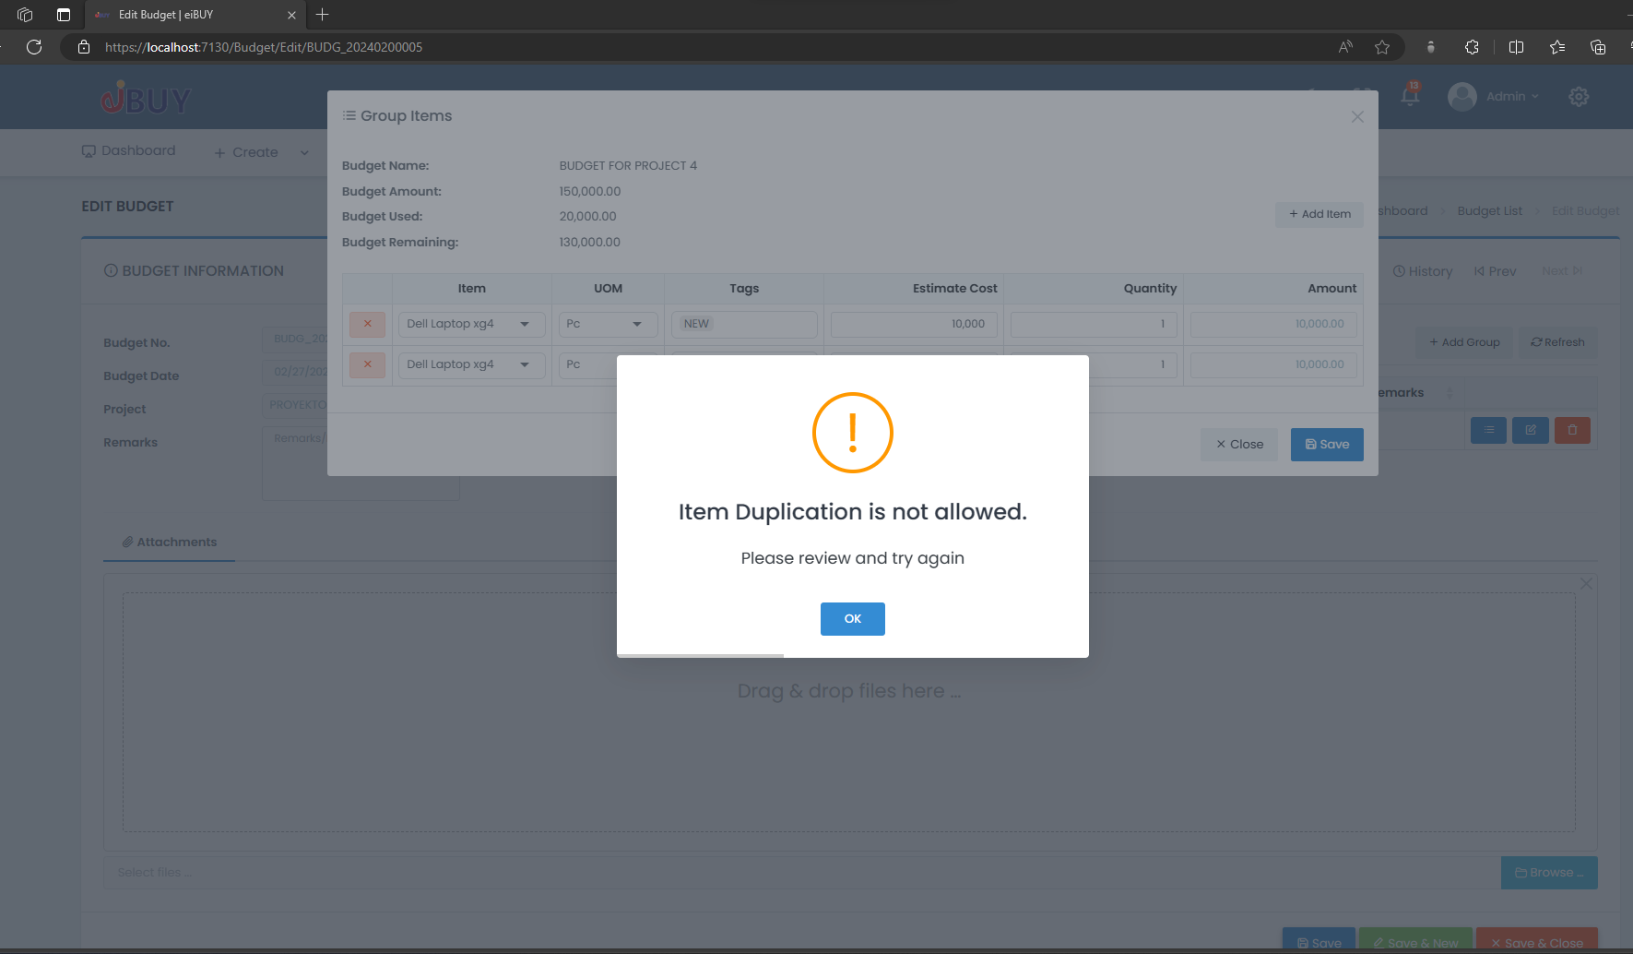

1. **Purchase Request > Inputting qty that is greater than the quantity in Budget.**

The entered quantity exceeds the allocated budget. Please review and adjust the quantity accordingly.

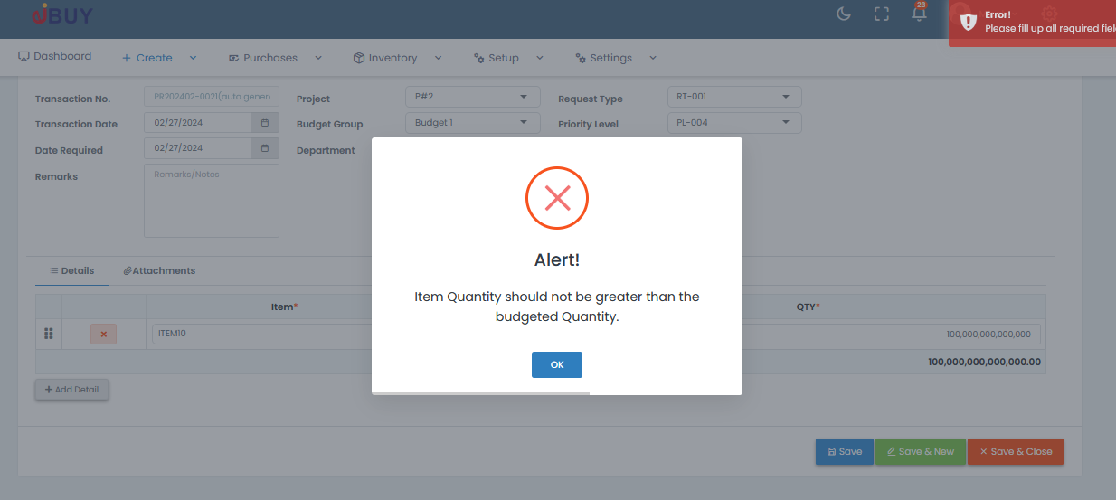

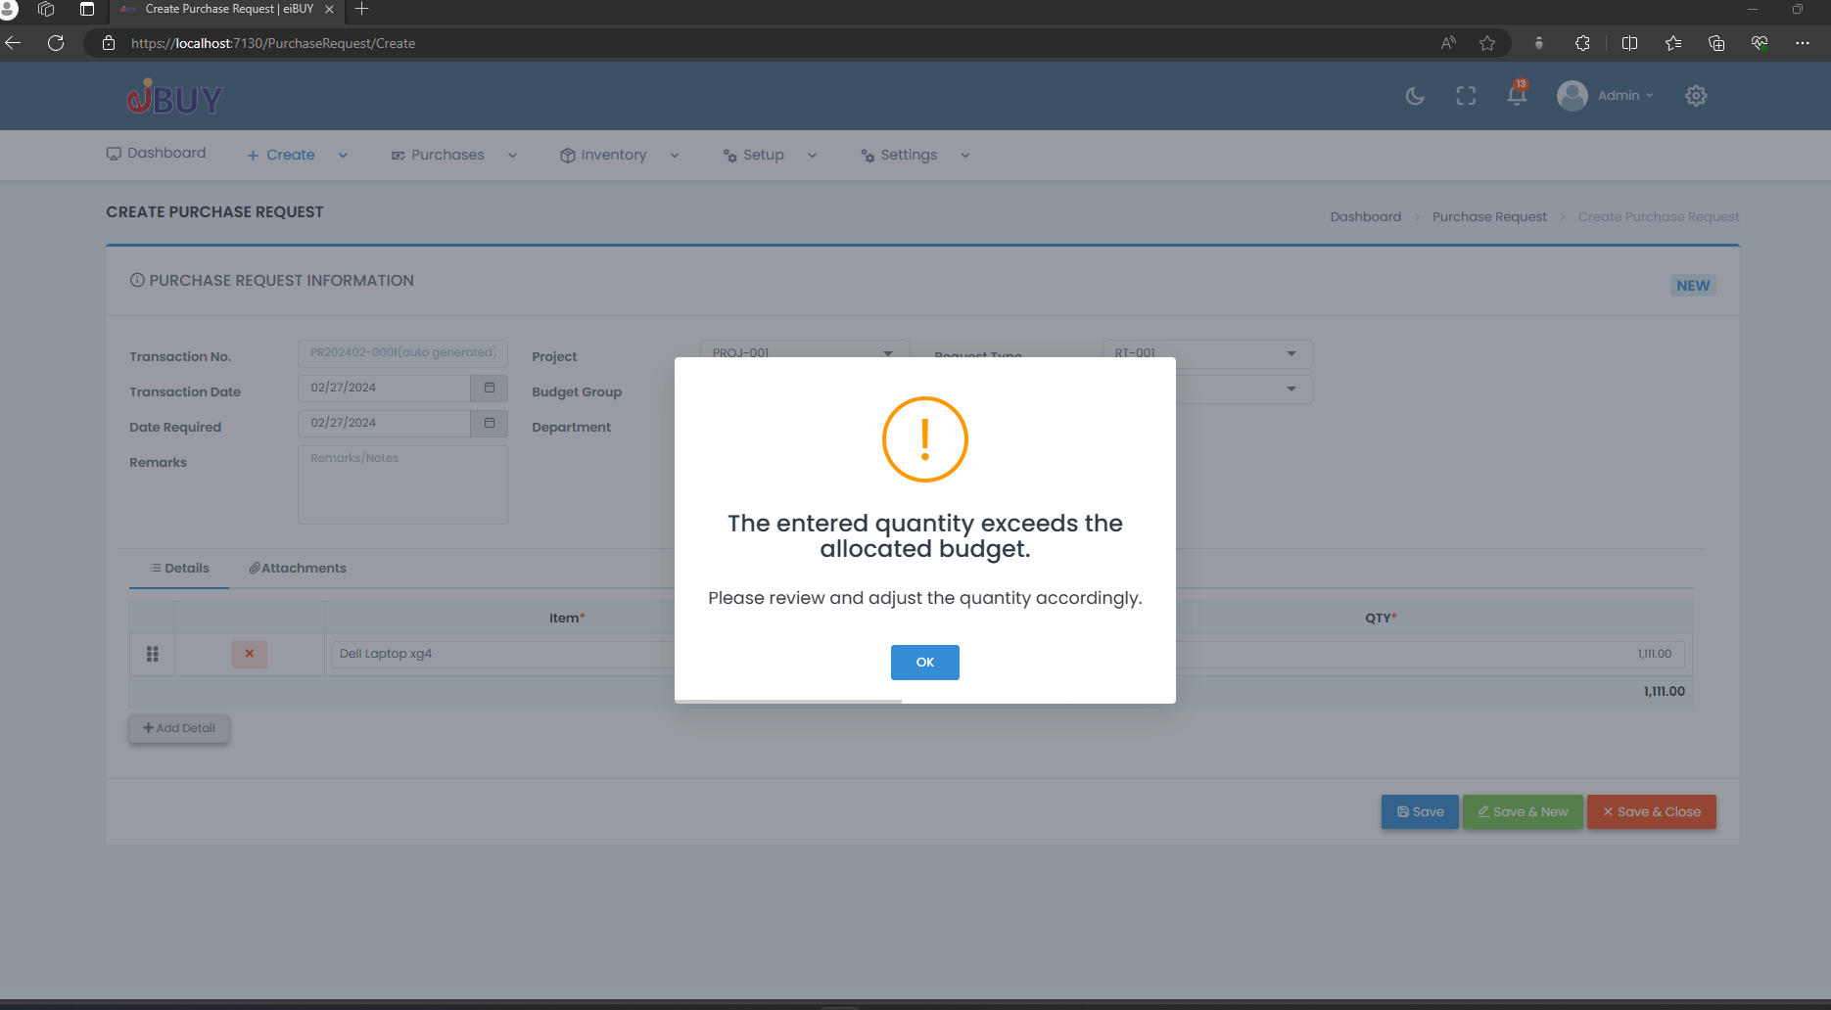

1. **Purchase Order > Selecting Duplicate Item.**

Item duplication is not allowed. Please review and try again.

1. **Purchase Order > Overbudget.**

Over budget. Please review and make the necessary changes to avoid exceeding the budget.

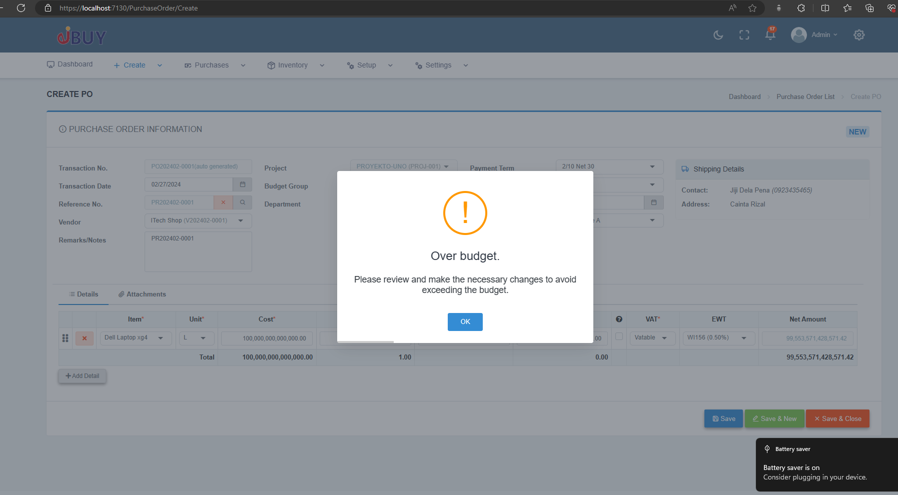

1. **Budget > after inputting a budget group amount that exceeds the initial budget amount.**

Budget amount exceeds the initial budget amount. Please review and enter a valid budget within the initial limit.

1. Budget > Add Item > Inputting amount that exceeds the budget amount of the budget group.

Item amount exceeds the allocated budget.

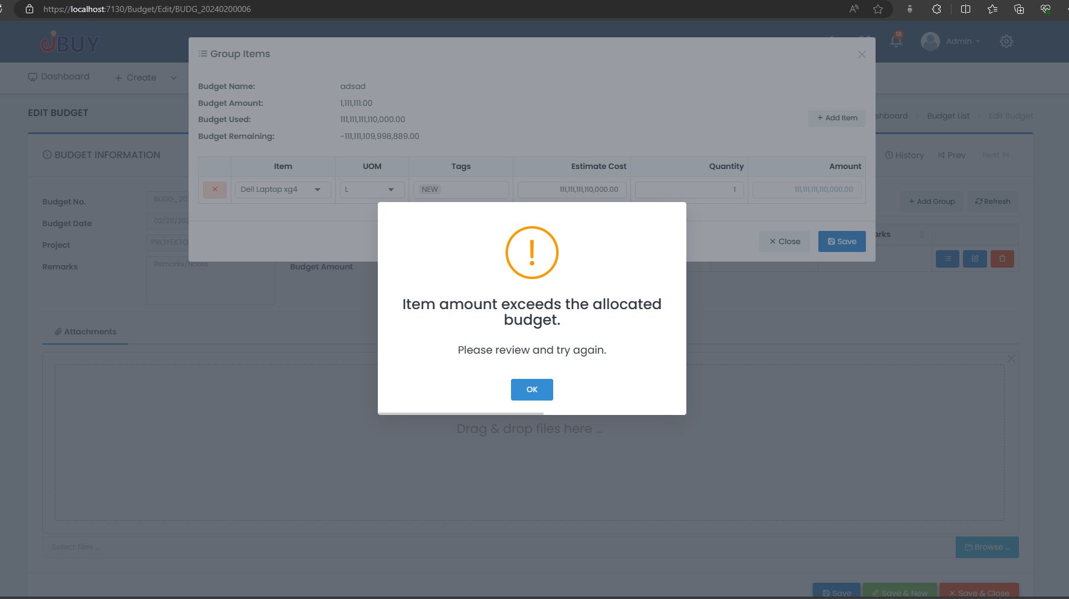

1. Budget > Edit > Add Budget Group > Input amount that is greater than the initial budget amount.

Budget amount exceeds the initial budget amount.

Please review and enter a valid budget within the initial limit.

